
Name:_______________
Year 11 Modern History
Unit 1 Understanding the Modern World
Elective 7: Capitalism – the American Experience 1907–1941
PRACTICE Source Analysis

- Evaluate the usefulness of Sources 1 and 2 as representations of the attitudes towards immigration in the United States during the time period. (5 marks)

______________________________________________________________________________________________________________________________________________________________________________________________________________________________________________________________________________________________________________________________________________________________________________________________________________________________________________________________________________________________________________________________________________________________________________________________________________________________________________________________________________________________________________________________________________________________________________________________________________________________________________________________________________________________________________________________________________________________________________________________________________________________________________________________________________________________________________________________________________________________________________________________________________________________________________________________________________________________________________________________________________________________________________

- Identify and account for the authors’ perspectives in Sources 1 and 2 regarding the specific changes described in the documents. (6 marks)
____________________________________________________________________________________________________________________________________________________________________________________________________________________________________________________________________________________________________________________________________________________________________________________________________________________________________________________________________________________________________________________________________________________________________________________________________________________________________________________________________________________________________________________________________________________________________________________________________________________________________________________________________________________________________________________________________________________________________________________________________________________________________________________________________________________________________________________________________________________________________________________________________________________________________________________________________________________________________________________________________________________________________________________________________________________________________________________________________________________________________________________________________________________________________________________________________________________________________________________________________________________________________________________________________________________________________________________

- Explain the historical context of Source 2. (4 marks)
______________________________________________________________________________________________________________________________________________________________________________________________________________________________________________________________________________________________________________________________________________________________________________________________________________________________________________________________________________________________________________________________________________________________________________________________________________________________________________________________________________________________________________________________

- Evaluate the extent to which the two sources give an accurate insight into the significance of attitudes regarding immigration. (6 marks)
________________________________________________________________________________________________________________________________________________________________________________________________________________________________________________________________________________________________________________________________________________________________________________________________________________________________________________________________________________________________________________________________________________________________________________________________________________________________________________________________________________________________________________________________________________________________________________________________________________________________________________________________________________________________________________________________________________________________________________________________________________________________________________________________________________________________________________________________________________________________________________________________________________________________________________________________________________________________________________________________________________________________________________________________________________________________________________________________________________________________________________________________________________________________________________________________________________________

Sources
Source 1: The Statue of Liberty. Carved at the base of the statue was a poem by Emma Lazarus written in 1886.
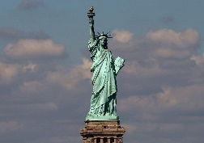
“Give me your tired, your poor,
Your huddled masses yearning to breathe free
The wretched refuse of your teeming shore.
Send these, the homeless, tempest-tossed to me;
I lift my lamp beside the golden door.”

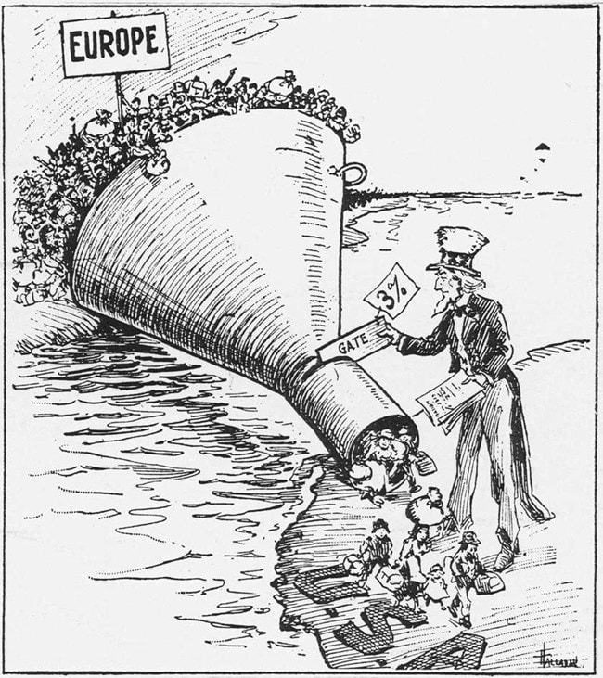
Source 2: A 1921 political cartoon portrays America’s new immigration quotas, influenced by popular anti-immigrant and nativist sentiment stemming from World War I conflict.
Name:_______________ /25
Practice Source Analysis – MARKING KEY
Marking key:
- Compare and contrast the messages of Sources 1 and 2.
Description | Marks
Reference to the messages in Source 1 and Source 2 | 1–2
Points of comparison of the messages in Source 1 and Source 2 | 1
Points of contrast of the messages in Source 1 and Source 2 | 1
Total | /4
Note: Evidence should be identified from the sources to support messages.

(b) Evaluate the usefulness of Sources 1 and 2 as representations of the attitudes towards immigration.
Description | Marks
Provides examples of Source 1 as a representation of attitudes towards immigration | 1–2
Provides examples of Source 2 as a representation of attitudes towards immigration | 1–2
Evaluates the usefulness of the sources | 1
Total | /5
Note: The response should include, where appropriate, both the strengths and weaknesses of the sources provided, in terms of how they are representative of attitudes towards immigration

(c) Explain the historical context of Source 4.
Description | Marks
Identifies the focus of the source | 1
Outlines the causes or events that led to the focus of the source | 1
Provides specific details for the focus of the source, dates/events/people/place/ideas | 1–2
Total | /4
Note: This question is concerned with the historical context in which the source is located. The answer must concentrate on what is in the source and explain the relevance/significance.

(d) Identify and account for the authors’ perspectives in Sources 1 and 2 regarding immigration described in the documents.
Description | Marks
Articulates the perspective of Source 1 | 1
Articulates the perspective of Source 2 | 1
Analyses of the perspectives in relation to the question asked. This may include discussion of:  • motives  • bias  • time  • place  • purpose | 1–4
Total | /6
Note: The response should:
- analyse the perspectives of the sources in terms of the theme/force
- articulate the perspectives from which the sources were constructed or analyse reasons for the perspective (purpose/motive/place/and time)
- use evidence of the perspective from the source
- identify how the author shows the perspective in the source.

e) Evaluate the extent to which the two sources give an accurate insight into attitudes regarding immigration.
Description | Marks
Articulates the different aspects of attitudes that are shown. | 2
Identifies aspects of change that have been omitted. | 1
Evaluates the extent to which the sources reflect the significance of attitudes toward immigration. | 1–3
Total | /6
Note: The response should:
- focus on what the sources say about change within the context studied, and why it may have been significant to highlight this

